**JIRYN CRIS JOY T. PAMERON**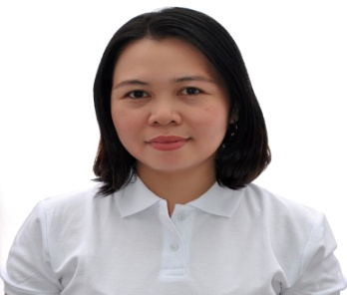

Blk.32 Lt. 74 Vamenta State Subd., Barra Opol Mis. Or.

jaitrabadopameron@gmail.com

jiryncrisjoytrabado@yahoo.com

contact no: 915 94507

pag-ibig no:1211-2799-0707

philhealth:15-050235695-1

sss no: 08-1760197-7

passport no: P1653397C

**OBJECTIVE**

To obtain a challenging position as Domestic Helper offering a cheerful disposition, knowledge of handling housework efficiently and determination to look after children teach and nurture them as well.

**PERSONAL INFORMATION**

Age : 39 yrs old

Birth Date : November 28,1984

Birth Place : Tibolo Sta. Cruz Davao del Sur

Height : 4’11

Weight : 53kl

Status : Married

Nationality : Filipino

Religion : Christian (Assembly of God)

**EDUCATION**

College : MSU (Mindanao State University)Bachelor of Science in Environmental Science 2001-2004

High School : Matangad National High School (1998-2001)

Elementary : Banaybanay Davao Central Elementary School(1992-1998)

Others : Technical Education and Skills Development Authority

**SKILLS**

**.** Experience of handling housework chores/ taking care of dog

. Dependable, accountable, honest, hardworking, and can express myself well

. Knowledge of first Aid

. Good communications and can manage a good relationship toward others

**QUALIFICATION**

**.** National Certificate (NC II ) for Food and Beverage Services

**WORK EXPERIENCE**

**.** DOMESTIC HELPER

Tseung Kwan O

July 24,2020 upto present

2 working adults and 1 baby

**.** DOMESTIC HELPER

Tai Po Hong Kong New Terretories

July 24, 2018 upto July 24,2020

Taking care of 3 adults and 1 medium dog

. DYNAPHARM INTERNATIONAL PHILS., INC.

Office Staff ( Nov. 16,2015 to Aug. 17,2017 )

*.* HARVESTFIELD RICE TRADING

Office Clerk ( Sept. 2014 – July 2015 )

*.* WAPHI PHARMACY

Pharmacist Assistant Cashier( January 2014 – July 2014 )

*.* THE GENERIC PHARMACY

Cashier ( May 2009 – December 2013 )

*.* SAVE ON GENERIC PHARMACY

Pharmacist Assistant ( April 2008 – April 2009 )

*.* NUGA BEST INC.

Lecturer/ VIP in charge ( January 2007 – March 2008 )

*.* BIJODA TERMINAL

Treasurer for drivers and conductor association (2004-2006)

*.* RIKA PHARMACY

Pharmacist Assistant (1999-2001)

**TRAININGS**

*1.* DENR (training for check releasing and encoding) (2011)

*2.* HOUSE KEEPING DEPARTMENT at Grand City Hotel  (2017)

*3.* FOOD AND BEVERAGES DEPARTMENT at Grand City Hotel (2017)

*4.* TESDA TRAINING for OFW 2018